
Certification Management Application

Prepared For
CRM SFDC Training Program
Capgemini Technology Services

Prepared By
Simran Gupta
Emp Id - 46022545

Abstract :
The Certification Management Application is a salesforce-based application for the management of certifications and vouchers. The application is made using the tools such as process builder, approval process, apex triggers provided by salesforce. The application uses the following 4 custom objects:
1. Employees
2. Certifications
3. Vouchers
4. Certification Requests
The main purpose of this application is to allow the employees of an
organisation to request for the certification and the respective voucher easily.The application also allows to keep track of different employees passed or failed in different certifications using the reports tool provided by salesforce. The application also leverages the power of Lightning Web Components for building the user interface for the application.

Scope:
The Following is the functionality which is provided by the system. Over here, there are 2 categories of people using this system. Each of them has their pros in the app.
- App Admin
- Create, Edit, Update and Delete all objects.
- Approve or Reject the Certification Requests.
- View and Edit the Reports and Dashboard.

- App User
- Create, Edit, Update and Delete Employees
- Create, Edit, Update and Delete Certification Request
- Update the Pass and Fail Status of the Employee.
- View and Edit the Reports and Dashboards
- View the Certifications and Vouchers in the System.

The Out Scope of the app include
- The application does not include the Employee login
- The employee can only share his details and see his status on the page
- The employee certification registration page is not autonomous.
- Third Party integrations are not yet included, except for Emails.

Class & Methods - Objects:
1.Employee Object
The Employee Object in Salesforce is used to Store the necessary details about the Employee.
Fields:
- Employee ID (Auto Number)
- Employee Name (Text)
- Email (Email)
- Primary Skill (Text)
- Secondary Skill (Text)
- Experience (Number)
- Comments (Long Text Area)

2.Certification Object
The Certification Object in Salesforce is used to store the details related to the certification
Fields:
- Certification ID (Auto number)
- Certification Name (Text)
- Cost (Currency)
- Comments (Long Text Area)

3.Certification Request Object
The Certification Request Object Aka Request Object in Salesforce is used to store the vital relationships of the Certification, Voucher, and Employee that is assigned by the App User.
Fields:
- Certification Object (Master Detail)
- Employee Object (Master Detail)
- Voucher Object (Look Up)
- Due Date (Date)
- Certification Request Id (Auto Number)
- Status (Picklist)
- Draft
- Approved
- Rejected
- Passed
- Failed
- Comments (Long Text Area)

4.Voucher Object
The Voucher Object in Salesforce is used to store the Voucher codes and the voucher related information.
Field:
- Voucher ID (Auto Number)
- Voucher Name (Text)
- Voucher Cost (Formula)
- Certification Object (Look Up)
- Validity (Date)
- Active (Checkbox)
- True
- False
- Comments (Long Text Area)

Simplifiers – UML Diagrams
Class Diagram
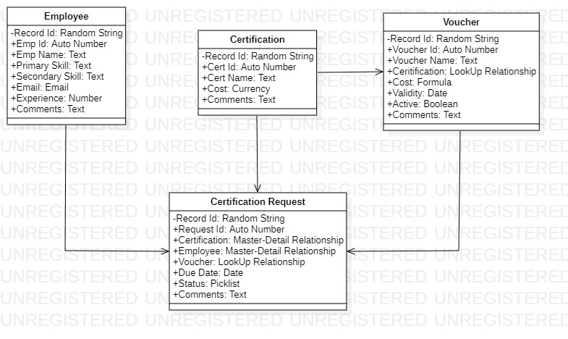

Use Case Diagram

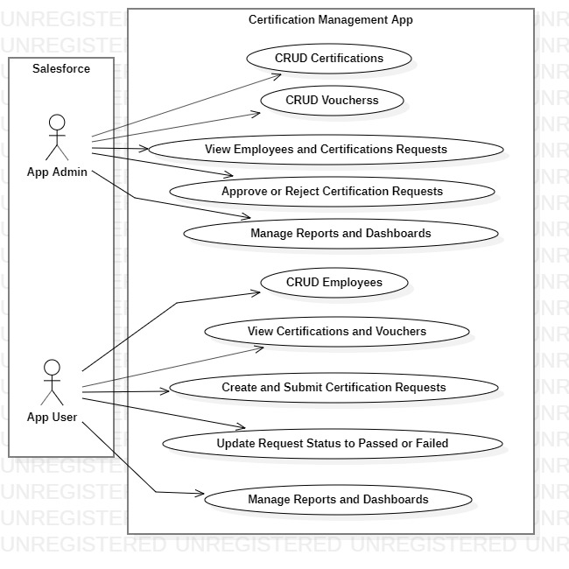

Sequence Diagram (Admin)

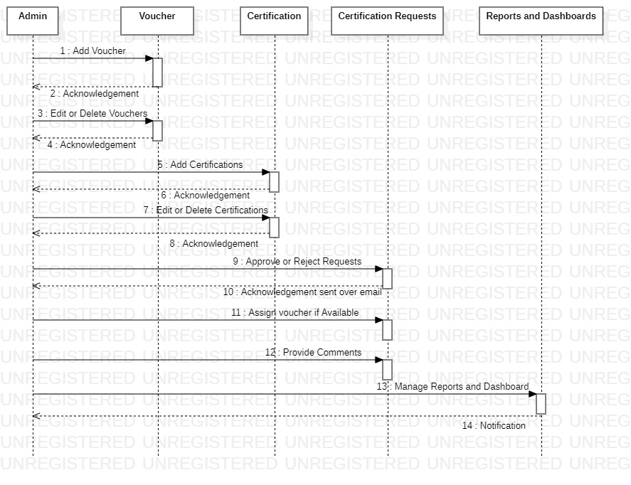

Sequence Diagram (User)

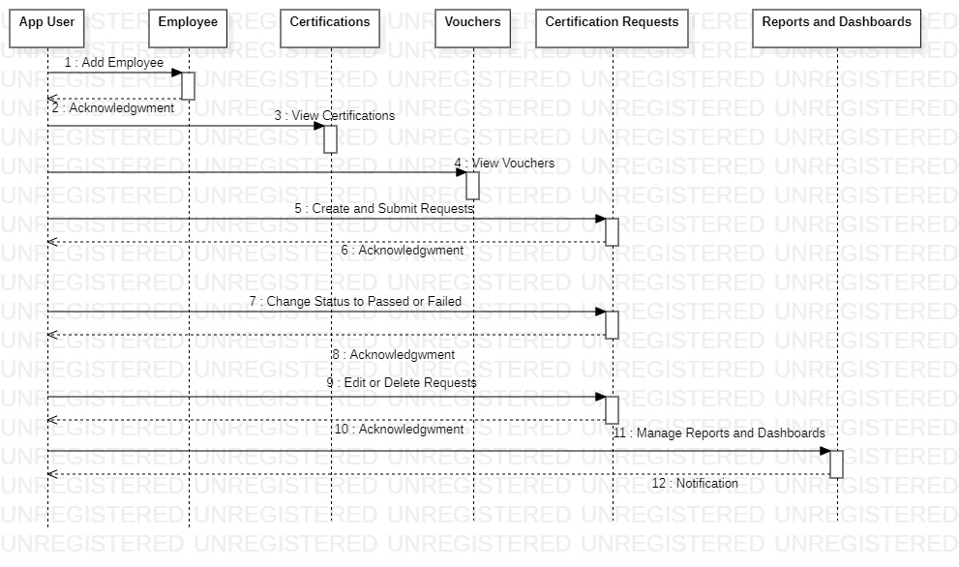

Activity Diagram (Admin)

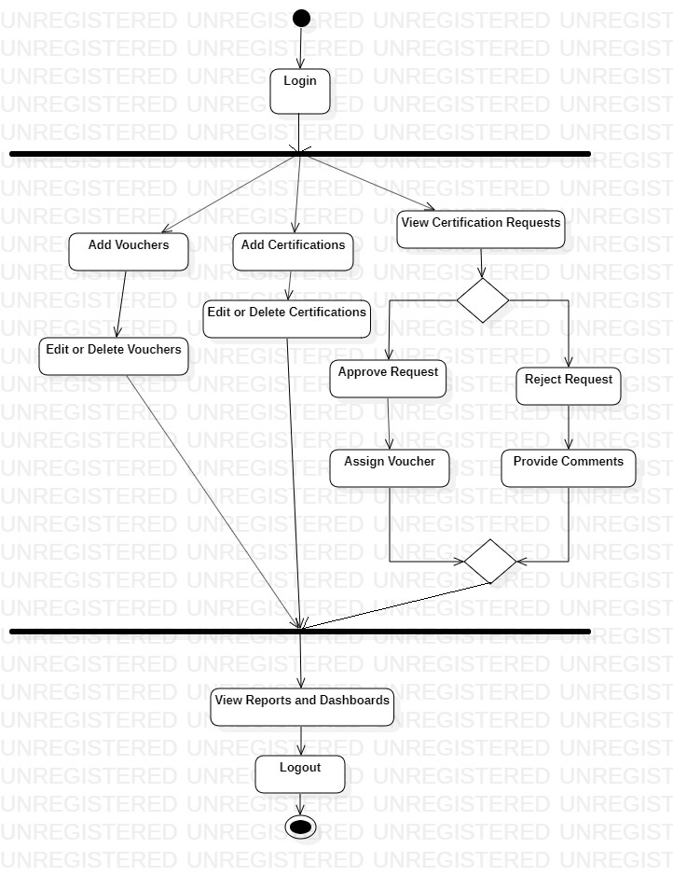

Activity Diagram (User)

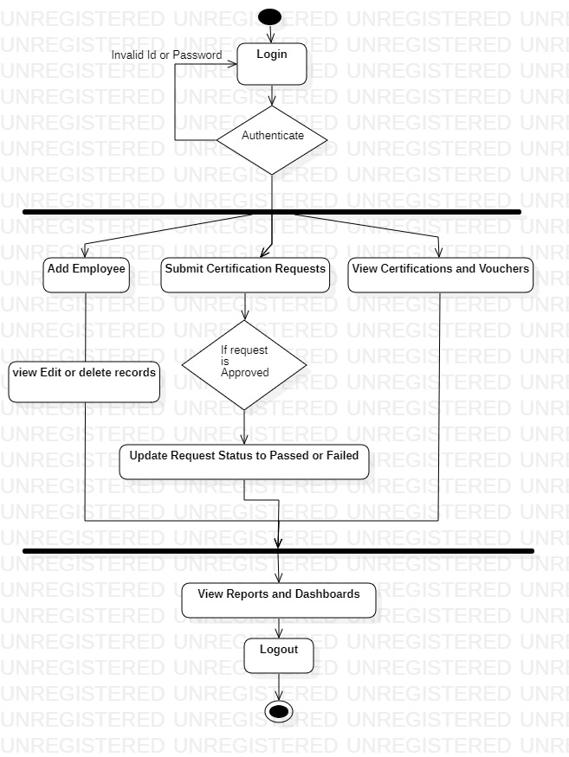

Flow Chart

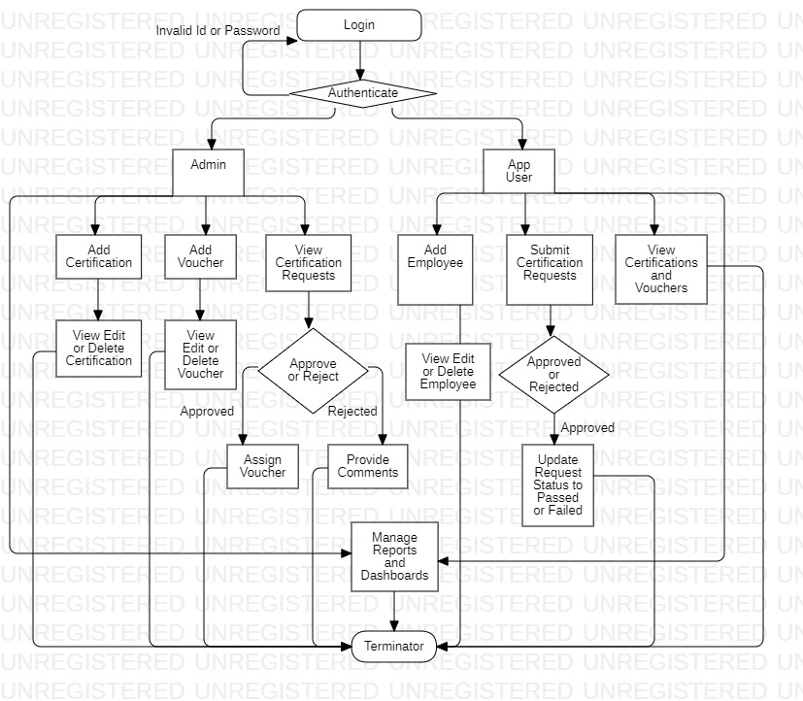

Routing – Approval process & Process builders
Approval Process:
There is one approval process "Approval for vouchers" for this project. The initial submission actions are field update which sets status field to draft and one email alert to app user saying request have been submitted. Final approval actions include one email alert to app user

and one field update, changing status field to approved. Final rejection actions include two field updates, one changing the status field to rejected and one changing the comment on Certification Request object to 'Voucher not received'.
Process Builder:

There are 6 Process builders which have been utilized over here. They are:
- Email to employee
- Email when approved
- Due date passed
- Sending Notifications
- Builder for all Requests
- Email when rejected

1.Email to employee:
The 'Email to employee' is an invocable process builder and is used to send email to the employees when their request is submitted to the admin.There is no such entry criteria in this builder. It directly sends the email to the employees.

2.Email when approved:
The 'Email when approved' is an invocable process builder. It is used to send email to employee when their request is approved by the admin. There is no such entry criteria in this builder. It directly sends the email to the employees.

3.Email when rejected:
The 'Email when rejected' is an invocable process builder. It is used to send email to employee when their request is rejected by the admin. There is no such entry criteria in this builder. It directly sends the email to the employees.

4.Due date passed:
The 'Due date passed' is an invocable process builder. It is used to send email to employee when due date is passed of certification request. There is no such entry criteria in this builder. It directly sends the email to the employees.

5.Sending Notifications:
The 'Sending Notifications' is used to send notification to app user that your certification result needs to be updated in the sysytem. The entry criteria is:
- If status is Draft and
- Due date less than TODAY()
then call the process builder 'Send Notifications'.

6.Builder for all Requests:

The process type for this builder is record change and the object is Certification Request.The first criteria has two conditions:
- Status is null - True
- Voucher is null -False
if both satisfies then it performs two immediate actions:
- calls process 'Email to Employee'
- submits the approval process then evaluate the next criteria
The second criteria has two conditions:
- status is approved
- voucher is null - False
if both satisfies then it performs two immediate actions:
- set active status of voucher to false
- call process 'Email when approved'

The third criteria has two conditions:
- status is rejected
- voucher is null - False
if both satisfies then it performs two immediate actions:
- If validity of voucher is greater than TODAY(), set active status of voucher to true
- call process 'Email when rejected'

Fourth criteria has two conditions:
- Voucher is null - True
- Status is null - True
if both satisfies then it performs two actions:
- call process 'Email to employee'
- Submit approval process 'Approval for Vouchers' for approval and evaluate the next criteria

The fifth criteria has two conditions:
- status is approved
- voucher is null - True
if both satisfies then it performs one immediate actions:
- call process 'Email when approved'

The sixth criteria has two conditions:
- status is rejected
- voucher is null - True
if both satisfies then it performs one immediate actions:
- call process 'Email when rejected'

Validations – Triggers & Rules
Rules
The rules over here represent the Validations that the input and other details follow in order for the App to work in an Organized Manner. The rules that were used here include
- App user should not be able to raise the same certification voucher request again if one already exist.
- App User should not be able to add new certification voucher request in system if there is any pending request exist for that employee.
- Voucher Validity should be greater than today (the date is stored in the database).
- Request Due date should not be less than Today (the date is stored in the database).
- A Voucher should be Active for it to be applied.
- If a request has been approved and has no voucher, but a voucher is available, then it should be automatically applied.Same certification and Voucher cannot be used over again, if already used.
- If an employee gets passed/failed in any certification then system should not allow to App User to raise same certification request for that employee again.

Triggers:

There are three Apex triggers in this project -

1.Check Voucher (Certification Request):
This trigger helps us in checking if a Certification request is not being made with the same set of Certification and Voucher details, which were used previously (if any).

2.Existing_Employee (Certification Request)
This trigger helps us in checking if a Certification request is being made with an Employee who already has a request pending or approved.

3.AddVoucher (Certification Request)
This trigger comes into run only when a Request Status has been set to Approved without any voucher for that Request. If a voucher is available in the Voucher object for that certification (unused), then only this trigger will help in applying that voucher to the appropriate Request and deactivate that voucher.

Assumptions
The things that are presumed by this Application encompass a variety of features, some of which are
- The Employee mails for a Request
- The Employee can only see his details but cannot edit them.
- Employee results are passed over by mail.
- Reports and Dashboards have the time frequency set to the Current
- Financial Year, and this can be changed b the viewer accordingly, to fit his/her timeline.

Path – Application Flow
- The App Admin creates certification and voucher records in the system.
- Employee mails the app user to issue certification voucher.
- App User raises the certification request to the App Admin who in turn approves or rejects the request. The request is raised using Approval Process tool of salesforce. The Approval Process is fired as soon as a request is created.
- The Employee is notified when request is submitted by the App User via email.
- The App Admin also receives an email when a request is raised.
- If the App Admin approves the request, then, the employee and the App User receives a mail to notify them about the approval.
- The voucher will be assigned to the user when request is approved.If the App Admin rejects the request, then, the employee and the App User receives a mail to tell them about the rejection.
- The App Admin will provide some comments if the request is rejected.
- The employee will notify the App User about the status of certification after the request is approved.
- The App User will then change the request status to Passed/Failed based on the information provided by the employee.
- In case due date of request is passed and request is still not approved or rejected, then, the employee and the app user will receive a mail to notify them to update the status of request.
- The whole repeats over and over again.

Figures – App Snippets

Employee:

Add Employee

View Employee Table

View Employee Detail

Certification

Add Certification

View List of Certifications

View Certification Record

Certification Request

Add Certification Request

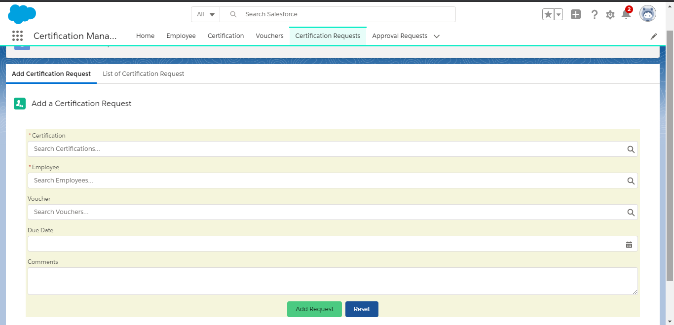

View Certification Request Table
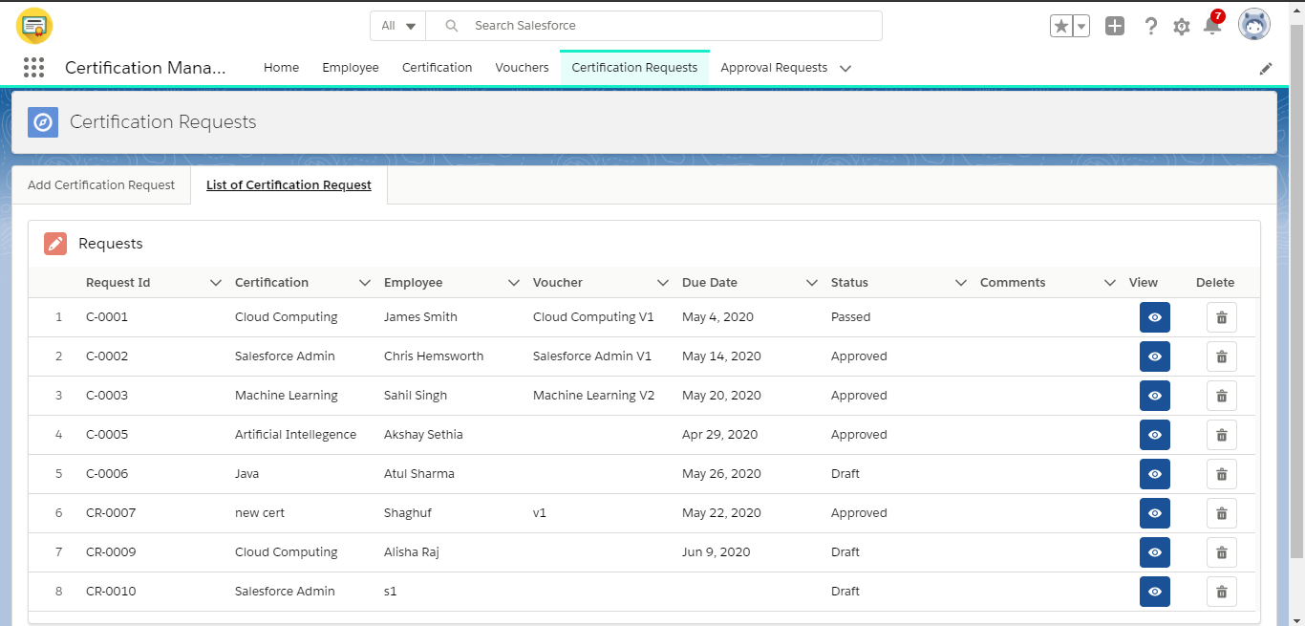

View Request Record
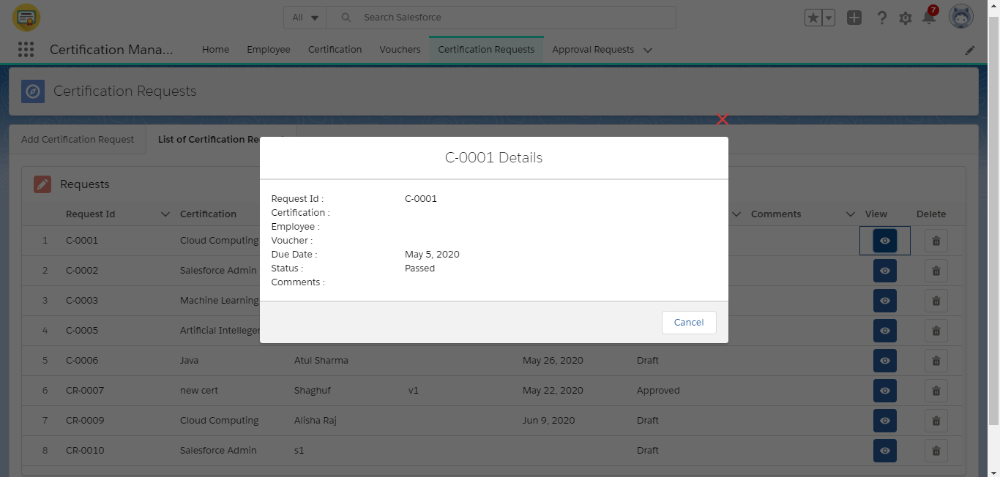

Voucher Object

Add Voucher
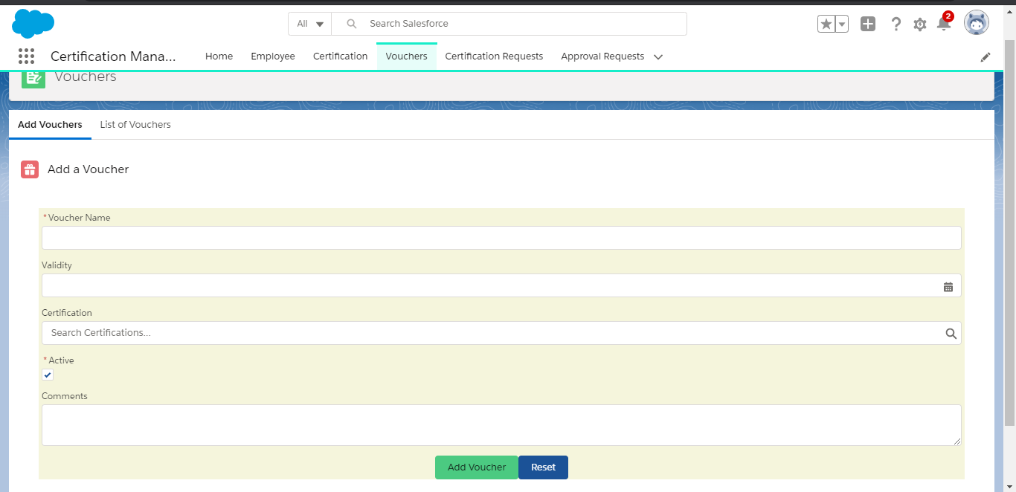

View Voucher Table

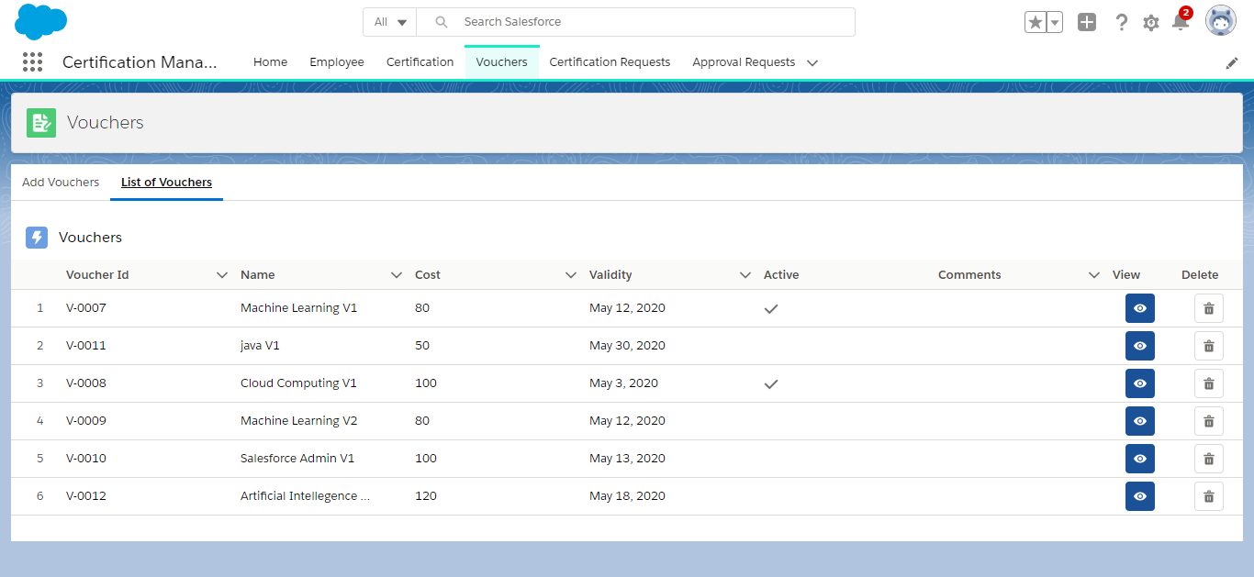

View Voucher Details

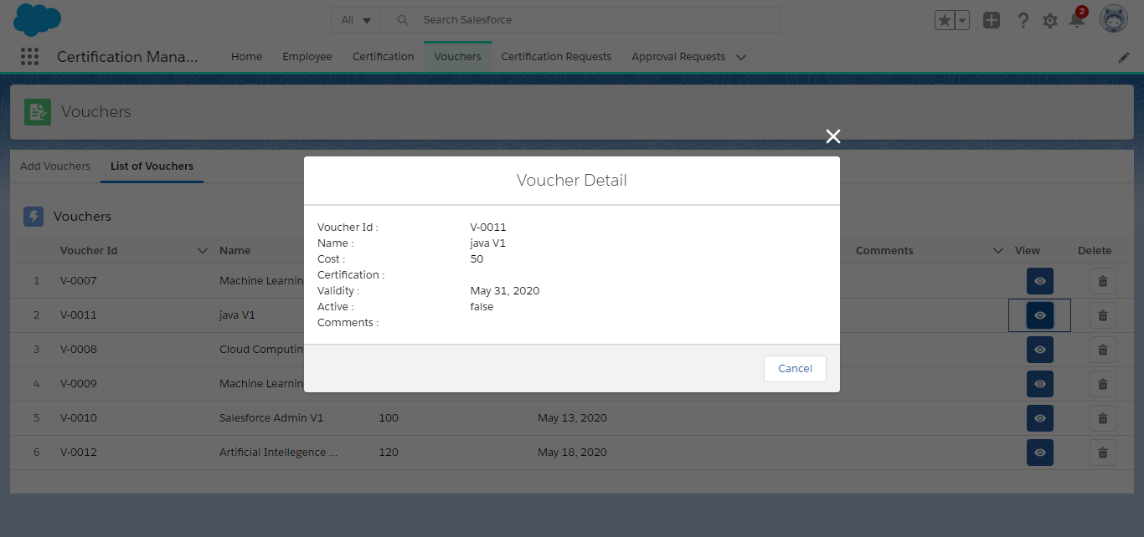

Home
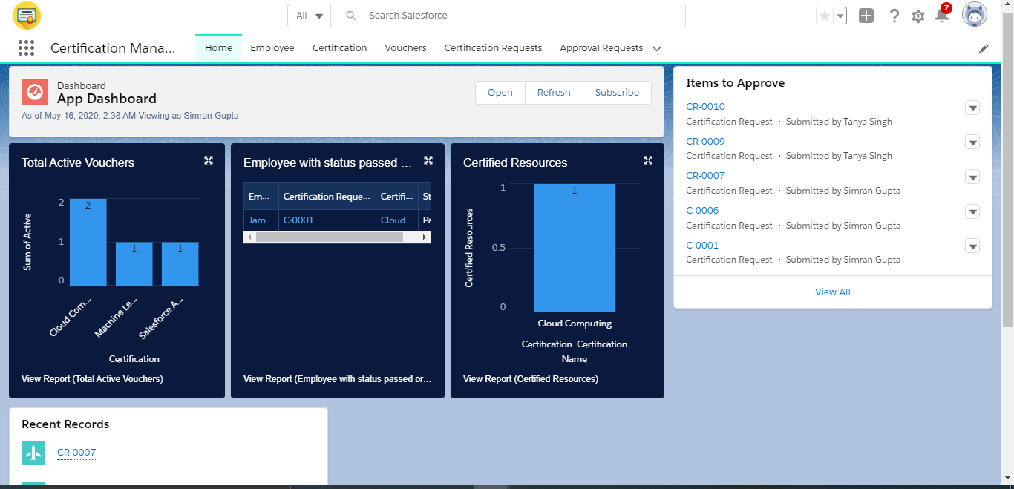

Conclusion
In Conclusion the Certification Management application is the best way to take the advantage of today’s technology to serve the society or an organization in order to increase the efficiency and productivity. This application helped the organization also to keep track of data properly.

